Day in the Life of the Hudson River 10/14/21
Pier 1 Lighthouse Museum, Staten Island
RIVER MILE: -4.5
Salt Front: ~ 49
Dave Scheffler & Curtis High School
12 students & 2 adults
Latitude 40.640951 N & Longitude – 74.073463 W
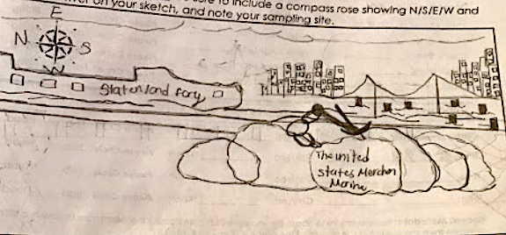

Location: Pier 1 Lighthouse Museum, Staten Island, NY
Area: Pier with parking lot.
Surrounding Land Use: 100% Urban
Sampling Site: Wood bulkhead, concreate bulkhead, banks altered, riprap
Shoreline: 20% sandy, 30% muddy, 50% rocky.
River Bottom: Rocky
Water : Calm
*NR = Not read/recorded
ITEM |  | Time |  | Reading |  |  |  | Comments
Physical
Air Temperature |  | 10:23 AM |  | 28.5 º C |  |  | 83.3 º F
Wind Speed: |  | 10:23 AM |  | Anemometer  2.6 mph |  |  | Beaufort  NR | Direction  SW
Weather today |  | 10:23 AM |  | <25% cloud cover |  |  | No rain
Weather the past 3 days: |  | Cloudy, humid, 70-80 degrees
Tides- |  | Time |  | Rising, Falling, Unchanged |  |  | Height (cm)
 |  | 10:10 AM- 12:11 PM |  | Rising  Rising |  |  | 213.36 cm  243.84 cm
Current- |  | Time |  | Cm/sec |  | Knots | North/South | Ebb/Flood/Slack
 |  | 10:39 AM  12:18 PM |  | 4.76  3.41 |  | 0.093  0.068 | South  South | Ebb  Ebb
Water Temperature- |  | 10:58 AM |  | 22º C |  |  | 72 º F
Turbidity- Long Sight Tube |  | 10:51 AM |  | 101.5 cm
Chemical
Salinity- Hydrometer |  | 11:03 AM |  | 18.33 ppt
Standardized Salinity- NR
DO – NR |  | Time |  | Temp |  |  | ppm DO | % Saturation
 |  | NR |  | 22 º C |  |  | NR | NR
pH – Color Match Kit |  | 11:12 AM |  | 7.67
Nitrates- strip tests – not a good tool for the field |  | 11:22 AM |  | Test results were extremely high  1 mg/L
Phosphates-strip tests - not a good tool for the field |  | 11:12 AM |  | Test results were extremely high  25mg/L
Biological
Fish - |  | Number |  | Name |  |  | Length of longest | Length of smallest
*Oyster Cage
Fish Totals |  | TOTAL: 0 |  | Diversity: 0
Macroinvertebrates |  | Number |  | Name |  |  | Length of longest | Length of smallest
Macroinvertebrate Totals |  | TOTAL:0 |  | Diversity: 0
Sediment Core
Length | H2S smell |  | Oxid Top |  | Oil |  | Grain Size | Other Features
NR | No |  | Yes |  | NR |  | Abundant: clay  Common: mud, sand | Common: macroinvertebrates, shells, living vegetation
Boats-NR
 | Time |  | Name |  | Color |  | North/Southbound | Light/Loaded
Commercial | 10:18 AM |  | Large Boats (unable to get name) |  | Dark Grey |  | Southbound | Loaded
 | 10:18 AM |  | Large Boats (unable to get name) |  | Red, Dark Blue & white |  | Southbound | NR
 | 11:22 AM |  | Large Boats (unable to get name) |  | White & Blue |  | Southbound | Light

